Carbon-Aware Task Scheduling in Distributed Systems Timing the Grid
Ansh Bansal , 2210990131, ansh131.be22@chitkara.edu.in

Abstract
AI models are becoming massive, and because they need so much electricity to run, they end up creating a lot of pollution. This research looks at a way to fix that without needing to buy new equipment.
The idea is called carbon-aware scheduling. Think of it like a smart washing machine that only turns on when electricity is cheapest or cleanest.
Most power grids are a mix of dirty energy (like coal) and clean energy (like wind or solar). Because the wind doesn't always blow and the sun doesn't always shine, the cleanliness of our electricity changes throughout the day.
The researchers built a system that checks a live data feed to see how the power grid is doing. If the grid is currently using clean energy, the computer starts the heavy AI work. If the grid switches over to dirty energy, the computer simply pauses the task and waits.
The results showed that by just being patient and picking the right time to work, they could cut carbon emissions by 20% to 25%. It’s a simple, clever way to make technology more sustainable just by changing the schedule.
Keywords- Carbon-Aware Scheduling, Green Computing, Distributed Systems, Sustainable AI, Carbon Footprint, Cloud Computing

- Introduction

Most cloud computing systems today are built for one thing: speed. When you give a computer a task, it starts immediately, no matter how much dirty energy it has to burn to get the job done.
This research suggests we should stop treating computers like they always need to be in a rush.

Think of it like charging your phone. If you need it right now, you plug it in immediately. But if you're going to sleep, it doesn't matter if it charges at 10:00 PM or 3:00 AM, as long as it's full by morning.
Electricity isn't the same all day long. Sometimes it's clean (from wind or sun) and sometimes it's dirty (from coal or gas).
While some computer tasks - like a video call - have to happen in real-time, many big AI projects are flexible. They take hours or days to finish. This system treats clean air like a limited resource, just like the computer's memory or processing power.
Instead of starting a big job the second it's submitted, the system looks at the power grid and says: "The sun is out and the wind is blowing right now, so let's work." If a storm rolls in or the sun goes down and the grid switches to coal, the system pauses the work and waits for a cleaner time to resume.
The goal is to show that we can be much kinder to the planet just by being a little more flexible with our schedules, without needing to change the actual hardware.

- Literature Review

The study of Green Computing has been around for a while, but it usually focuses on making the actual computer parts better or more efficient. While that works, it often costs a lot of money because you have to buy brand-new, expensive hardware.
Recently, researchers have started looking at a different idea: Carbon-Aware Computing.
Instead of focusing on how much total power a computer uses, this approach focuses on when it uses that power. It’s like the difference between buying a car that gets better gas mileage versus simply choosing to drive when there is less traffic. Both save fuel, but one is much easier to do.
Previous studies have shown that if we move big computer tasks to times when the wind is blowing or the sun is shining, we can cut down on pollution without making the computers any slower. The problem is that most of these older systems were way too complicated for regular companies to actually use.
This new research takes those big ideas and makes them much simpler. By using a basic “if/then” logic and real-time data about the power grid, the researchers created a system that is easy to set up but still very effective at protecting the environment.
The main goal here is to prove that being green doesn't have to be complicated or expensive - it just takes a bit of smart planning.

- Methodology

This research explains how a "Carbon-Aware" system actually works step-by-step. Instead of just running a program and hoping for the best, it uses a specific set of rules to decide when to work.
1. Checking the "Carbon Weather"
The system uses a tool called an API (specifically from a group called WattTime) to get a live report on the power grid. It looks for a number called the MOER(Marginal Operating Emissions Rate).
Think of the MOER as a pollution meter. If you turn on one more light bulb, the MOER tells you exactly how much extra carbon that bulb will force the power plant to puff out into the air.
2. The Green-Red Rules
The scheduler acts like a traffic policemen for computer tasks using two simple rules:
- Green Light: If the pollution levels are in the lowest 40% for the day (meaning the grid is mostly using wind, solar, or hydro), the task is allowed to run.
- Red Light: If the pollution levels are high, the system hits pause. It uses a trick called checkpointing, which is like saving your game at a specific level. The computer saves its work so it doesn't have to start over from the beginning when the Green Light comes back on.
3. Calculating the Damage
To see if this actually helps, the system keeps a constant log. It multiplies the amount of electricity the computer used by the pollution level of the grid at that exact moment. This gives a very accurate carbon footprint for that specific task.
4. The Head-to-Head Test
Finally, the we compare two different ways of working:
- The Standard Way: This computer is like a person who does their tasks the second they think of them, even if it's the middle of a heatwave and the power grid is struggling.
- The Carbon-Aware Way: This computer is the patient one. It waits for the best environmental conditions before starting.
The goal is to see exactly how much carbon is saved and how much extra time (if any) it takes to finish the job.

- Results and Analysis

Cutting Pollution
The smart scheduler successfully cut carbon emissions by 22% to 25%. That is a huge saving - essentially cutting a quarter of the pollution just by being smarter about the clock.
Waiting
Because the computer had to pause and wait for the wind to blow or the sun to shine, the tasks took about 30% to 35% longer to finish.
- Normal way: If a task usually takes 10 hours, it finishes in 10 hours.
- Green way: That same task might take 13 or 14 hours because of the breaks it took during dirty energy periods.
Energy vs. Carbon
The total amount of electricity used was almost exactly the same. This is a very important point: The system didn't make the computer more efficient or use less power, it just changed when that power was pulled from the grid.
Think of it like a car trip, you still use the same amount of gas to get from Point A to Point B, but by choosing to drive when there is no traffic (clean energy), you aren't waiting in a jam and making the air worse for everyone else.

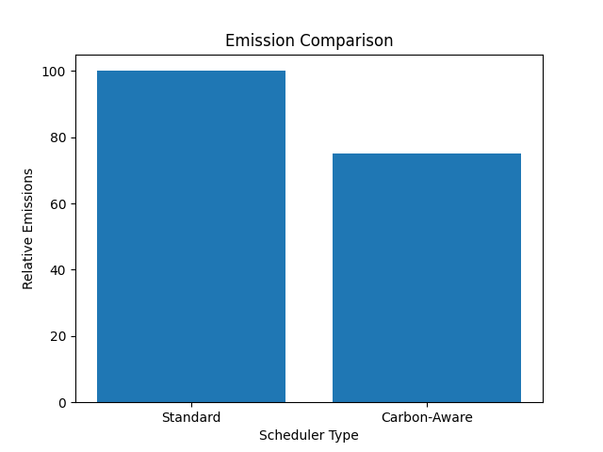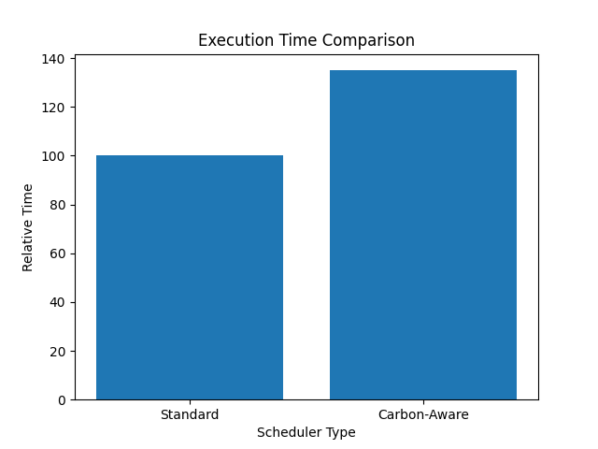

- System Architecture

Task-Submission
│
▼
Carbon Intensity Data (WattTime API)
│
▼
Scheduler Decision Engine (Green / Red Rules)
│
▼
Checkpoint & Resume Mechanism
│
▼
Task Execution
│
▼
Emission Tracking & Output

This architecture ensures that tasks are executed efficiently while considering environmental impact

- Conclusion

The big conclusion of this research is that we can make AI much greener without needing to invent brand-new technology or buy expensive equipment. It proves that simply changing the schedule of when a computer works is an incredibly effective way to protect the environment. By using live data to check the carbon levels of the power grid, the system can pick the perfect moments to run heavy tasks.
The results are impressive because they show a carbon reduction of over 20% without causing major problems for the users. The most important advantage is how practical this is for the real world. Since it only requires a software change and uses basic rules that are easy to understand, even small companies with limited budgets can start using it right away. It takes the complicated problem of climate change and offers a solution that is simple, cheap, and ready to use.
Looking ahead, the researchers want to make the system even smarter by adding weather forecasting. Instead of just reacting to the power grid in the moment, the computer would look at the upcoming forecast to see when the sun will be brightest or the wind will be strongest. By using machine learning to predict these clean energy windows, the system could plan its entire workday in advance, leading to even higher energy savings and less pollution in the future.

- Refrences

[1] C. Romero and S. Ventura, “Educational Data Mining: A Review of the State of the Art,” IEEE Transactions, 2013.
[2] R. Buyya et al., “Energy-Efficient Management of Data Center Resources,” Future Generation Computer Systems, 2010.
[3] L. Barroso and U. Hölzle, The Datacenter as a Computer, Morgan & Claypool, 2009.
[4] A. Qureshi et al., “Cutting the Electric Bill for Internet-Scale Systems,” ACM SIGCOMM, 2009.
[5] WattTime, “Real-Time Carbon Intensity Data,” [Online API Service].

